MOP Launching Campaign – IMC Brief
Details
Background: For MOP launching campaign which will happen around end of May – beginning of June this year, there is a need for an integrated communication plan and main creative assets (KV, TVCs or animation, etc.) to be developed. These will help to introduce to target customers the main benefits of MOP

Objective: to shout out that McD is launching a brand-new customer centric feature in GMAL app in order to ensure app installs and feature trials to bring in committed GCs and sales

Target Audiences:
The same current target of McDonald’s but more tech-savy. They are willing to explore new things when it comes to technology, especially when it promises a new and convenience experience. They should familiar and use smartphone often in a daily basis.

Key message: MOP can elevate speed and convenience when it come to customers’ experience and reinforce “Feel good moment” message of McDonald’s in overall by allowing customers to order and pay right in GMAL app.

Look & Feel for KV:
- Focusing on natural and spontaneous positive moments
- Bright and vibrant colors
Reference
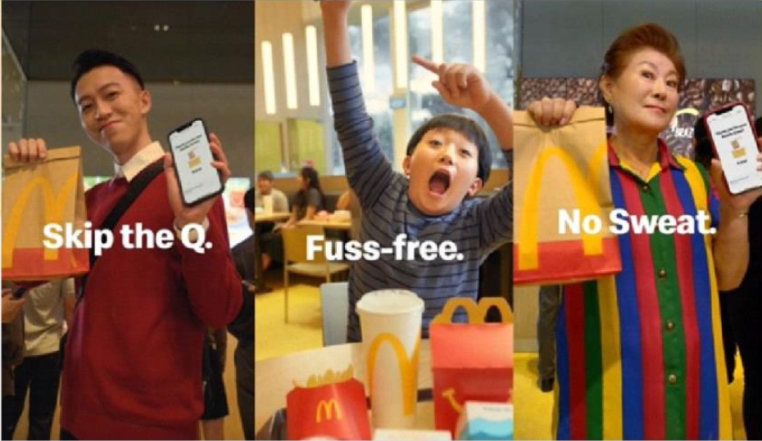
Deliverables:
- Campaign tagline
- Key visual
- Animation (optional)
- Integrated Communication Plan (social content plan should be included)
- Media plan to create FOMO and drive traffic to store (optional)
- Digital banner adaptation: Web banner, App banner
- POSM adaptation: table sticker, SOK cover, SOK welcome banner, horizontal A4 tentcard, standee, A3 leaflet

Mandatories:
- Should feature people using app on smartphone
- My McDonald’s Rewards Logo
- Highligt MOP Ordering Screen
Budget: VND 150,000,000

About MOP & Its features: you can access all materials about MOP here

